Operating System APIs

Definition
# Source: AI Source: Provided by: [Data Path: Persons Table -> ID Column: 1, Name_En Column: Motasem Essam] -> From: [ChatGPT] on [1/19/2026]
An Operating System (OS) API is a set of predefined functions provided by an operating system that allows software programs to interact with the computer’s hardware and system resources safely and easily.

Simple Definition
# Source: AI Source: Provided by: [Data Path: Persons Table -> ID Column: 1, Name_En Column: Motasem Essam] -> From: [ChatGPT] on [1/19/2026]
OS API = a bridge that lets programs use the computer’s hardware and system features without managing the hardware directly.

How OS APIs Work
# Source: AI Source: Provided by: [Data Path: Persons Table -> ID Column: 1, Name_En Column: Motasem Essam] -> From: [ChatGPT] on [1/19/2026]
- A program calls an OS API function (like reading a file or opening a window).
- The operating system performs the action behind the scenes.
- The program gets the result without dealing with low-level hardware details.

Examples of OS APIs
# Source: AI Source: Provided by: [Data Path: Persons Table -> ID Column: 1, Name_En Column: Motasem Essam] -> From: [ChatGPT] on [1/19/2026]
- File management – open, read, write, delete files
- Memory management – allocate or free memory
- Process management – start, stop, or control running programs
- Input/output operations – handle keyboard, mouse, or screen
- Network operations – send and receive data over the network

Examples by Operating System
# Source: AI Source: Provided by: [Data Path: Persons Table -> ID Column: 1, Name_En Column: Motasem Essam] -> From: [ChatGPT] on [1/19/2026]
- Windows API (WinAPI) – used for Windows programs
- POSIX API – used in Linux and Unix systems
- MacOS Cocoa API – used for macOS applications

Difference Between OS API, Library API, and Web API
# Source: AI Source: Provided by: [Data Path: Persons Table -> ID Column: 1, Name_En Column: Motasem Essam] -> From: [ChatGPT] on [1/19/2026]
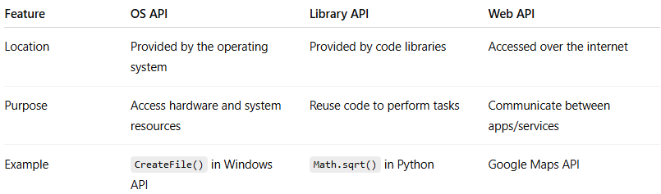
Feature | OS API | Library API | Web API
Location | Provided by the operating system | Provided by code libraries | Accessed over the internet
Purpose | Access hardware and system resources | Reuse code to perform tasks | Communicate between apps/services
Example | CreateFile() in Windows API | Math.sqrt() in Python | Google Maps API

Why OS APIs Are Useful
# Source: AI Source: Provided by: [Data Path: Persons Table -> ID Column: 1, Name_En Column: Motasem Essam] -> From: [ChatGPT] on [1/19/2026]
- Programs can access hardware safely
- Simplifies development by handling complex system tasks
- Ensures compatibility across devices

